# Animation GUI

## Purpose:

This GUI provides an animated plot that gives a visual representation of the physical responses of the quadcopter from the simulation output data. This GUI was developed to provide a more intuitive view of simulation output than can be offered by simple 2D graphs of aircraft Euler angles and states. It displays the quadcopter’s attitude relative to the inertial frame, and also displays the quadcopter’s position in the inertial frame. The animation is able to display the quadcopter in either the “X” or “+” configurations automatically depending on which quadcopter model (quadModel.mat) file is currently stored in the Workspace. The Animation GUI can be seen below in .

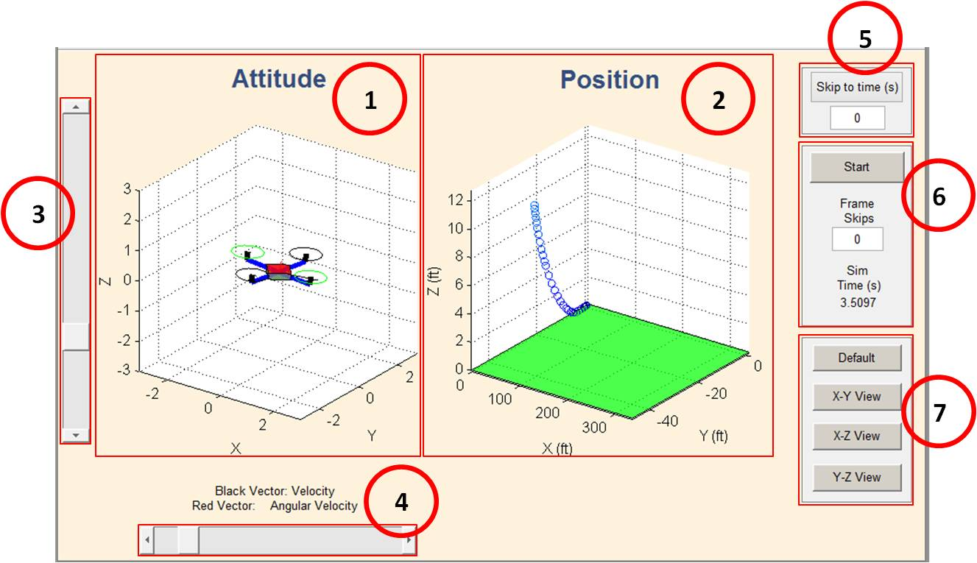

*Figure 1. Animation GUI*

## Description:

1. Attitude: displays the vehicle’s attitude. Also displays arrows for the angular velocity (red) and the velocity (black) vectors.
2. Position: displays the position of the vehicle in the inertial frame. It plots the 3D trajectory of the quadcopter through each time step of the simulation. The path marker color is changed with time to give an additional element of time information.
3. Vertical slider: change the elevation viewing angle during the animation
4. Horizontal slider: change the azimuth viewing angle during the animation
5. Skip to Time: allows for the user to begin the animation from a specific time during the simulation, instead of always requiring the animation to start from t = 0s. Type in a time (seconds), click the button, and the animation is ready to start from that time. If this button isn’t used, the animation will default to starting at t = 0s.
6. Start button, Frame Skips button, and Simulation Time display: First, the user can select the Start button to begin the animation from whatever the “Skip to Time” value is entered (see note 5). The “Frame Skips” button is used to either speed up or slow down the animation by setting the step size to take for plotting. “0” plots every frame (every moment for which simulation state data exists), “1” plots every other frame by skipping one frame each plot, and so on.
7. Snap to View buttons: these buttons are used for setting specific viewing angles during the animation. Instead of attempting to drag the sliders to get a perfect viewing angle in a certain plane, these buttons allow for quickly setting different plane views, or the default viewing angle.

NOTE: Exiting the animation by closing the window while the animation is running will cause an error to be displayed at the command line. To avoid this, just pause the animation before closing the GUI window.